 | YEAR 9 COMMON  EPW 1 – SEMESTER 1 2018  Pascal’s Triangle and Mice Maze |  |  | 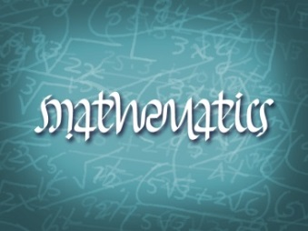
Name: ___________________________ |  |  | Teacher: _________________________
EPW Weighting: 10% of the year  Time: 35 mins |  |  | Common Marks: ________/25  Accelerated Marks: _________/30
Equipment Allowed: Take home component

PART B – Validation

SECTION 1: PASCALS TRIANGLE ( 8 marks)
- Below is an extract from Pascals Triangle. Determine each of the unknown values. [8 marks]

SECTION 2: MOUSE ESCAPE (12 marks – 6, 1, 5)
PLACE VALUES ON ALL INTERSECTION POINTS TO GAIN FULL MARKS
The diagram below shows a maze network with TWO traps. Determine how many ways the mouse can reach the exit without going through the traps given that the mouse can only move down or right.
Number of ways the mouse can reach the exit without going through the traps = ______________
Next, a piece of cheese has been placed on one of the intersections in the next diagram.

- How many ways can the mouse reach the cheese given that the mouse can only move down or right?

No of ways the mouse can reach the cheese = ______________

- Hence or otherwise, determine the number of ways the mouse can reach the exit if it wants to collect the piece of cheese on the way. Remember, the mouse can only move down or right. (Show how this is done on the diagram above)

No of ways the mouse can reach the exit if he wants to collect the cheese on the way = ___________

SECTION 3: Optional for Common Class (5- 2, 3 marks)
- The mouse has been re-trained and is now only allowed to move up or right. How many ways can the mouse reach the exit if he wants to collect the cheese on the way?
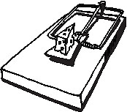

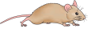
EXIT

- Below is a maze that has 56 possible routes. Place 2 traps on any of the labelled intersections so that the number of possible routes is reduced to 26. The mouse can still only move up or right. Use the mazes on the next page to help you find your answer.

Which two intersections did you place your traps? ______________

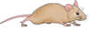

EXIT
P
D
H
L
B
C
E
A
F
I
M
G
J
Q
N
R
K
O
S
T
U
V
EXIT
P
D
H
L
B
C
E
A
F
I
M
G
J
Q
N
R
K
O
S
T
U
V





EXIT
P
D
H
L
B
C
E
A
F
I
M
G
J
Q
N
R
K
O
S
T
U
V
EXIT
P
D
H
L
B
C
E
A
F
I
M
G
J
Q
N
R
K
O
S
T
U
V
EXIT
P
D
H
L
B
C
E
A
F
I
M
G
J
Q
N
R
K
O
S
T
U
V
EXIT
P
D
H
L
B
C
E
A
F
I
M
G
J
Q
N
R
K
O
S
T
U
V

